Neuadd Eglwys

Llanllawddog

Bore Coffi Cymunedol

* Community Coffee Morning*

9fed Chwefror 2023

*9th February 2023*

**10am-12noon**

**Dewch i fwynhau cwmni, paned a sgwrs**

***Come and enjoy some company and a cuppa***

**Wi-Fi ar gael am ddim / Free wi-fi available**

***Bydd yr eglwys ar agor hefyd***

**The church will also be open**

**Mae mynediad am ddim, ond croesewir rhoddion**

***There is no charge for this coffee morning however donations would be welcome.***

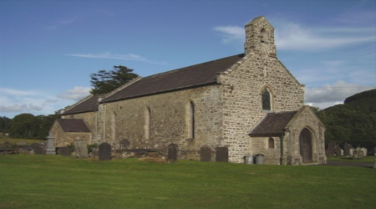[**Fran.j.dixon@btinternet.com**](mailto:Fran.j.dixon@btinternet.com)

**078 151 47239**