Community & Town Councils
Biodiversity Action Plan
Environment (Wales) Act 2016 Part 1 – Section 6 The Biodiversity and Resilience of Ecosystems Duty
Name of Community & Town Council: | Llanllawddog Community Council
Council type (Group 2 NRAP Objectives): |  | 2
Introduction and Context
Llanllawddog is a small rural Community Council in the County of Carmarthenshire, a few miles to the north of the town of Carmarthen. The Community comprises the villages of Pontarsais and Rhydargaeau, straddling the A485 together with outlying areas. The population has increased from 706 (Census 2021) to 765 (Census 2022).

The Council’s precept for 2026-27 has been set at £8,803. The Council is not subject to the Well-being of Future Generations (WFG) Act, but the Council is supportive of the intentions of the Act.

The Community Council is made up of 8 Members and employs a part-time Clerk.

In October 2024, the Council completed on a land transfer from a developer and now owns an area of land which the Council developed as a play area in the summer of 2025. The play area measures 165 square metres. Following that land acquisition the Council is now a Group 2 organisation and must report on NRAP Objectives 1,2,3,4,5 and 6.

The area attracts many visitors’ being walkers, dog walkers and cyclists from outside the area to enjoy the outdoor amenities. Part of the area is on the National Cycle Route Network. Green spaces and contact with nature provide a number of health benefits both mental and physical.

Within Llanllawddog, there is a large area of commercial forestry owned by Natural Resources Wales.

The National Security Global Biodiversity Loss Eco-System Security Report released in January 2026 demonstrates that the World is seeing biodiversity loss including crop failures intensified natural disasters and infectious disease outbreaks.

Within the Council’s area there is an area of common land known as Mynydd Ystyfflau Carn Common which has a shared boundary with Abergwili Community Council. The Common is designated as a Site of Special Scientific Interest. The Common is subject to a recent application by the County Council for consent to construct works on common land in accordance with the Commons Act 2006 Section 38. The purpose of the application is to improve biodiversity.

NRAP  Objective | Biodiversity objectives | Action planned | Milestones | Completed by | Achieved | Monitored by:
1 | -embed biodiversity into decision making & procurement | There will be a standing item on each Council agenda on Biodiversity, with that agenda item scheduled early in the meeting to focus minds on Biodiversity.  A budget for biodiversity and nature projects will be included in the annual budget in 2027-28.  Address biodiversity concerns when commenting on planning applications and being supportive of applications which demonstrate biodiversity through conservation and providing new habitat.  Address biodiversity issues from the outset when considering any potential land acquisitions. If a suitable piece of land is identified, at the heart of any project must be a net increase in biodiversity by adopting beneficial practices, avoiding chemical applications and improving sensitive habitats.  To encourage groups to approach the Council for support which promotes habitat improvement emphasising that requests for financial assistance are looked upon more favourably. | Agreed by Council – January 2026  By including it in the Budget setting in 2027-28  Ongoing  Ongoing | At every meeting  January 2027  Ongoing  Ongoing | Ongoing  Ongoing | Clerk  Council  Council  Council
1 | -raise awareness of biodiversity & its importance | The Council will be supportive of suitable groups such as walking, cycling and rambling to encourage the importance of biodiversity.  The Council will promote on its website and Facebook page nature friendly initiatives, and erect a noticeboard in the play area displaying biodiversity information.  Approach Peniel School Eco-Council to ascertain interest in constructing bird boxes and bug hotels.  Post twice monthly on the Council’s Facebook page articles of nature interest and from Carmarthenshire Nature Partnership.  Add an extra tab on the website for Carmarthenshire Local Places for Nature Newsletters.  All Members of the Council and Clerk be encouraged to attend One Voice Wales Biodiversity Training. | Ongoing | Ongoing | Ongoing | Council
2 | -safeguard principal species and habitats | Introduce biodiversity through planters, bug hotels, bird and bat boxes and invertebrate improvement areas. | Ongoing | Ongoing | Ongoing | Council
3 | -restore & create habitats and resilient ecological networks | To encourage hedgehog and small mammal highways through permeable boundaries at the play area.  Investigate the feasibility of purchasing large tubs of planters to grow pollinator friendly species at the play area.  Contact County Council to identify any parcels of land to investigate the feasibility of the planting of fruit trees and pollinator planting on grass verges.  Apply for habitat boxes, bug hotels and bat boxes from One Voice Wales. | Ongoing  Ongoing  Ongoing  Approved by Council – January 2026 | Ongoing  Ongoing  Ongoing  Awaiting delivery of habitat boxes | Ongoing  Ongoing  Ongoing  Successful application made to One Voice Wales – February 2026 | Council  Council  Council  Council
4 | -tackle negative factors: for e.g. reduce pollution, use nature based solutions, address invasive species | The Council will not use pesticides, chemical sprays in its play area. The Council will ensure its contractors are aware of this requirement.  The Council will encourage members of the public to identify and report invasive species.  Investigate feasibility of bike racks at the play area to normalise cycling as an alternative to driving.  Approach the County Council for details of glyphosate usage, the frequency, quantities used and reason for use. If feasible to request its reduction.  To investigate dark skies as a habitat with an aim to reduce light pollution. | Ongoing  Ongoing  Ongoing  Ongoing  Ongoing | Ongoing  Ongoing  Ongoing  Ongoing  Ongoing | Ongoing  Ongoing  Ongoing  Ongoing  Ongoing | Council  Council  Council  Council  Council
5 | -use, improve, and share evidence | Use former telephone box as a surplus food swap for the community growing group and book exchange. | Ongoing | Ongoing | Ongoing | Council
6 | -support capacity and/or other organisations | Work with Natural Resources Wales and Public Rights of Way Department of the County Council to encourage footpaths to be cleared.  Work with Natural Environment and Sustainability Team of the County Council to raise awareness of local habitats on common land.  To review annually the late cut of road verges with the Highways Department and to investigate the feasibility of increasing the areas left to nature.  To work with the community growing group at the Village Hall.  To investigate with the Walking Group the feasibility of a nature-based walk to identify interesting species.  Invite the West Wales Rivers Trust to speak on river health.  To keep in touch with Vincent Wildlife Trust on progress being made on the re-introduction of wild cats. | Ongoing  Ongoing  Ongoing  Ongoing  Ongoing  Ongoing  Ongoing | Ongoing  Ongoing  Ongoing  Ongoing  Ongoing  Ongoing  Ongoing | Ongoing  Ongoing  Ongoing  Ongoing  Ongoing  Ongoing  Ongoing | Council  Council  Council  Council  Council  Council  Council
Annual review of the Biodiversity Action Plan |  |  | Date reviewed:
What has worked well?
What have the barriers been?
What will you change?
Next review due:
Approved by Council on:

Cynghorau Cymuned a Thref
Cynllun Gweithredu Bioamrywiaeth
Deddf yr Amgylchedd (Cymru) 2016 Rhan 1 – Adran 6 Y Ddyletswydd Bioamrywiaeth a Chydnerthedd Ecosystemau
Enw’r Cyngor Tref neu Gymuned:
Math o gyngor (Grŵp 1,2, neu 3 ar gyfer amcan NRAP)
Cyflwyniad a'r Cyd-destun
Disgrifiad byr o'r Cyngor, ei swyddogaethau a'r cyd-destun o ran:

- sut y gallai helpu bioamrywiaeth (trwy ei swyddogaethau rheoli tir, cyllid grant, gweithgareddau addysgol e.e.).

- graddfa ofodol a lle (e.e. faint o dir mae'n ei gynnwys, poblogaeth, praesept?).

- cyflawni gwasanaethau i'r cyhoedd (e.e. a yw gofynion Deddf Llesiant Cenedlaethau'r Dyfodol yn berthnasol iddo?).

Amcan  NRAP | Amcan Bioamrywiaeth | Camau arfaethedig | Graddfa amser | Wedi eu monitro gan:
1 | -cynnwys bioamrywiaeth o fewn llunio penderfyniadau a chaffael
1 | -codi ymwybyddiaeth o fioamrywiaeth a'i bwysigrwydd
2 | -diogelu prif rywogaethau a chynefinoedd
3 | -adfer & chreu cynefinoedd a rhwydweithiau ecolegol cydnerth
4 | -mynd i'r afael ag elfennau negyddol: lleihau llygredd e.e. defnyddio atebion yn seiliedig ar natur, mynd i'r afael â rhywogaethau goresgynnol
5 | -defnyddio gwella a rhannu tystiolaeth
6 | -cefnogi capasiti a/neu sefydliadau eraill
Adolygiad blynyddol o’r Cynllun Gweithredu Bioamrywiaeth |  |  | Dyddiad yr adolygiad:
Beth sydd wedi gweithio'n dda?
Beth fu'r rhwystrau?
Beth fyddwch yn ei newid?
Dyddiad yr adolygiad nesaf:
Cymeradwywyd gan y Cyngor ar:

Back
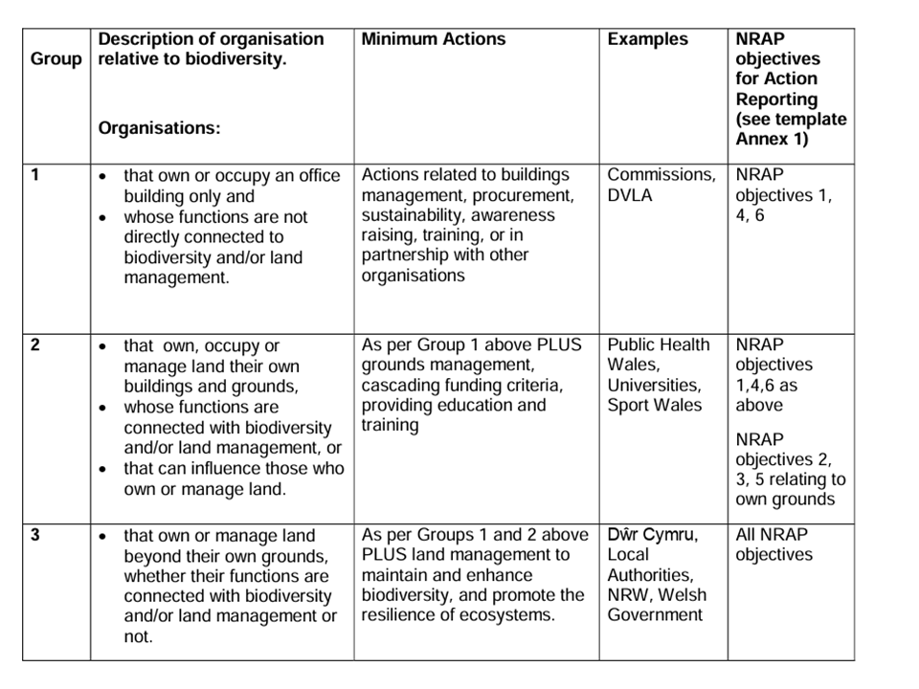
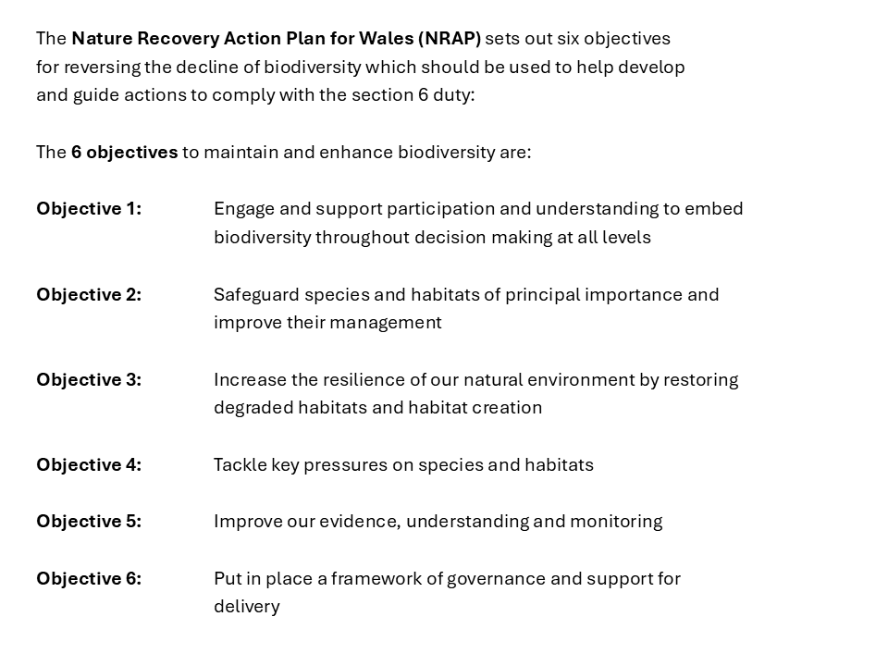

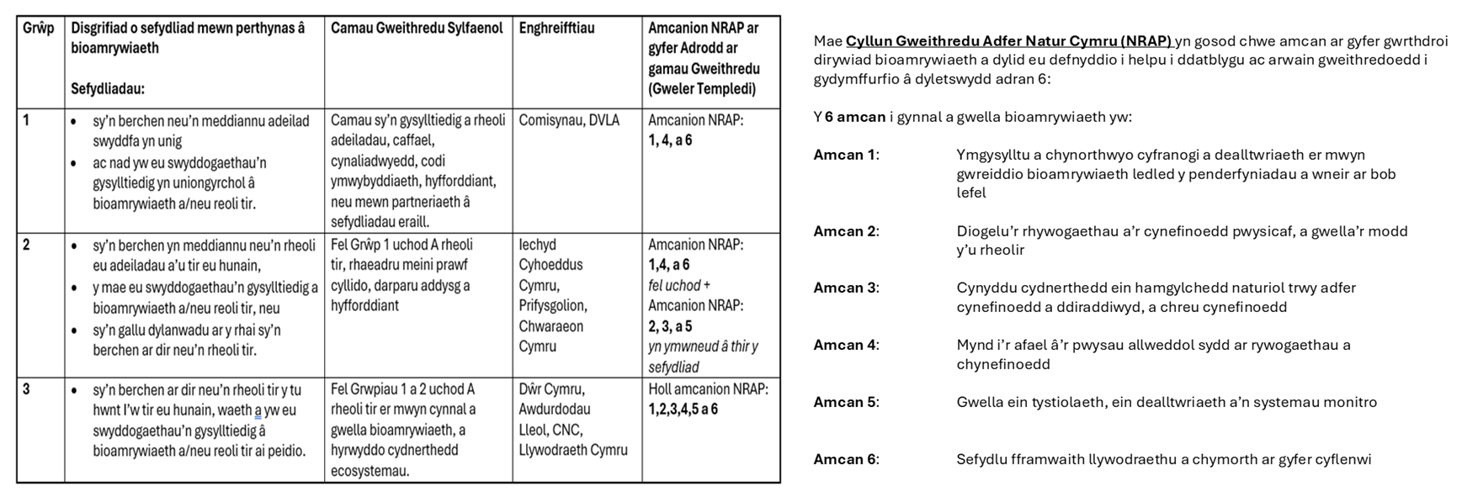
Nôl

