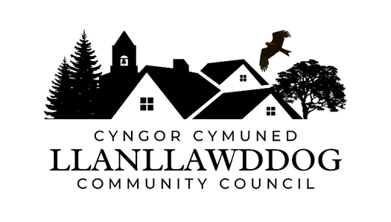
CYNGOR CYMUNED LLANLLAWDDOG COMMUNITY COUNCIL

ANNUAL REPORT 2025-26

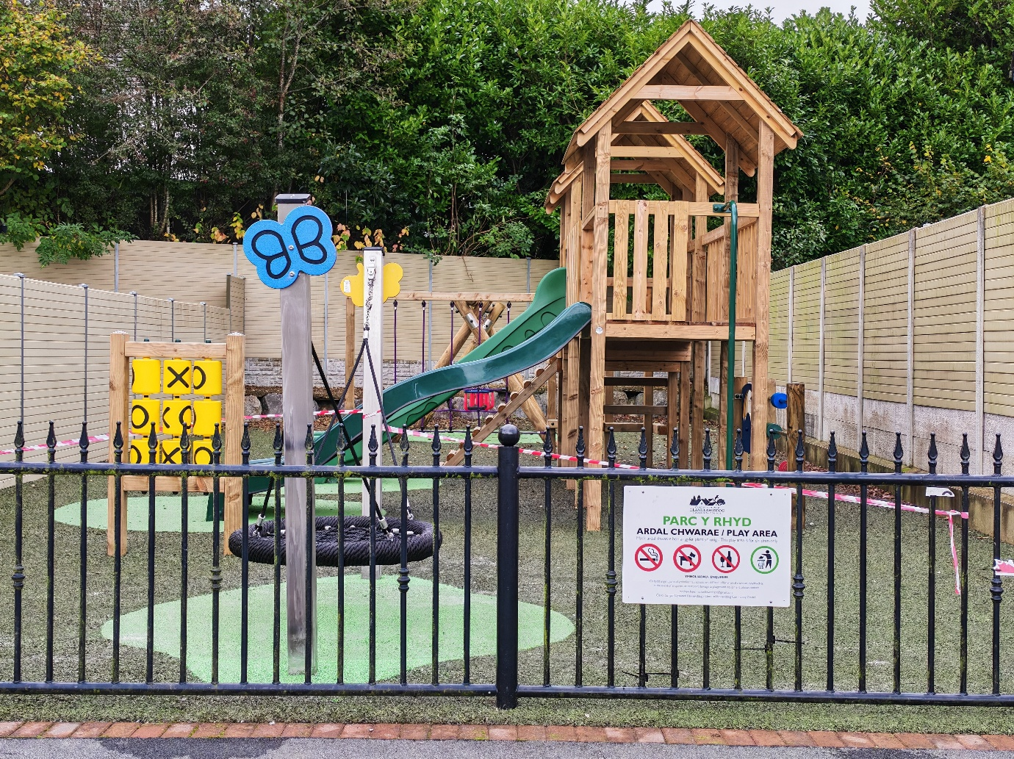

1. Introduction
1.1 Llanllawddog is a small rural Community Council in the County of Carmarthenshire, a few miles to the north of the town of Carmarthen. The Community comprises the villages of Pontarsais and Rhydargaeau, straddling the A485 together with outlying areas. The population has increased from 706 (Census 2021) to 765 (Census 2022).

1.2 The Community Council is made up of 8 Members who are either elected to serve a 5 year term or who are co-opted. The Quorum for the Council is 3.

2. Composition of the Council

2.1 The composition of the Council as 31 March 2026 is as follows:

Councillor Steven Mason (Chairperson)
Councillor Havard Hughes (Vice-Chairperson)
Councillor Nia Bowen
Councillor Deborah Dean
Councillor Elizabeth Gibbon
Councillor Philip Hughes
Councillor Darrell Lewis
Councillor Peter Williams

2.2 The Council at its Annual Meeting on 12 May 2025 re-elected Councillor Steven Mason as its Chairperson and Councillor Havard Hughes as Vice-Chairperson.

3. Clerk and Responsible Financial Officer

3.1 The Council employs a part-time Clerk and Responsible Financial Officer who is the Council’s Proper Officer.

3.2 The Council’s Clerk is Andrew Rees who has been in post since December 2022. His contact details are as follows:

Llanllawddog Community Council
75 Heol Pentre Felen,
Llangyfelach,
Swansea
SA6 6DW
07968 033075
ccllanllawddogcc@gmail.com

4. Meetings of Council

4.1 The Council meets six times a year in the months of January, March, May, July, September and November. All meetings take place at Llanllawddog Church Hall at 7pm unless otherwise indicated and are advertised on the Council’s Noticeboards and its website.

4.2 The Church Hall benefits from having Wi-Fi facilities and this has meant that the Council is able to comply with one of the requirements of the Local Government and Elections (Wales) 2021 Act in being able to hold multi-location meetings. During the year, Members of the Council have again successfully attended remotely when they have not been able to do so in person.

5. Finance

5.1 The Council at its meeting on 12 January 2026 set a precept of £8,803 for 2026-27, an increase of £322 from the level of precept in 2024-25. In increasing the precept, the Council was cognisant of the increase in the rate of inflation of 3.8% reported by the UK Government at the end of Quarter 2.

5.2 The Council’s income in 2025-26 was £16,582.24 made up as follows:

- Precept £8,481
- Interest £506.80
- Grants £1,496.00
- VAT Reclaim £6,099.44

5.3 The Council secured grant funding from the Brechfa Forest Wind Farm Fund for an additional Defibrillator Pads in the sum of £1496 to be located in Pontarsais.

5.4 The Council’s expenditure in 2025-26 was £46,524.73 made up of the Clerk’s salary, final payment of the play area installation, administrative costs, Members allowances and expenses, provision of public lighting, audit fees, insurance and donations. A breakdown is as follows:

5.5 The Council has made donations to the following organisations:

- Marie Curie Great Daffodil Appeal 2025 & 2026
- Carmarthenshire Shopmobility
- Regional Committee of Urdd Gobaith Cymru in West Carmarthenshire
- Tywi Gateway Trust
- Wales Air Ambulance
- Radio Glangwili
- Urdd Gobaith Cymru Fund for All Appeal
- Carmarthenshire Young Farmers Club

6. Audit of Accounts

6.1 The Council was subject to a full audit of its accounts by Audit Wales for the year 2024-25 and to date the outcome of the audit is awaited.

7. Activities and Achievements

7.1 The Council has achieved the following during 2025-26:

- Development of Parc y Rhyd Play Area in Rhydargaeau – Installation of the equipment and surfacing of the Council’s play area named Parc y Rhyd took place in June and July 2026. A fundamental to the design of the play area was to make it accessible to all young children and to promote inclusivity with the equipment reflecting that principle. In addition, the Council secured from Hywel Dda University Health Board a Communication Board featuring pictures, symbols and words to express needs, thoughts and ideas. The Council also purchased Trilingual and British Sign Language which are fixed to the fencing of the play area.

The Council secured a free Biodiversity package from One Voice Wales with the Council being granted materials to construct a planter, substrate to fill the planter and a selection of plants recommended by One Voice Wales Biodiversity Local Places for Nature Officer. The Council was also awarded as part of the package habitat boxes and bug hotels. Construction of the planter and the fixing of the habitat boxes and bug hotels took place in March 2026. Planting took place in April 2026 with the help of local children.

- Late Cutting of Verges – The Council made a successful request to the County Council for a later cut of verges in late summer or autumn for a second year. The initiative is designed to improve biodiversity, enhance wildflowers and pollinating insects. The exception to the later cut of verges was at junctions, bends or on busy roads, which required to be cut for pedestrian and driver safety. The Council has sought the agreement of the County Council for the practice of late cuts to continue.

- Community Litter Pick – The Council held 3 Community Litter Picks to date and further litter picks will be held during the year. In addition, the Council held a “Balsam Blitz” to eradicate Himalayan Balsam in the summer of 2025 around the area of the Afon Gwili prior to the seedpods forming to mitigate the further spread of the Himalayan Balsam.

- Facebook Page – The Council’s Facebook page continues to grow with 165 followers compared to 139 followers at the corresponding stage last year. The page is administered by the Clerk and 3 Council Members. Information published and shared on the Page has been as follows:

- Church Hall events
- Community Litter Picks
- Community Safety Information
- Location of Defibrillators
- Road Closures due to highway improvement works and road traffic accidents
- Carmarthenshire County Council News – School Admissions; Free School Meals; School Transport; School Closures due to snow; Bank Holiday Recycling and Refuse Collections; Christmas Tree Recycling; Budget Consultation and Travel Alerts
- Power Outages
- Water leaks
- Met Office Weather Alerts
- Play Area News
- Green GEN Cymru and Trydan Gwyrdd Consultation Events and Public Meetings

- Road Safety on the A485 – The Council continues to be concerned with the speed of traffic on the A485 and continues to lobby Carmarthenshire County Council for traffic calming and the provision of a safe crossing. The County Council has again installed speed monitoring equipment on two separate occasions. The results of the first speed monitoring revealed significant excessive speeding at nighttime. The results of the second operation are awaited. Dyfed Powys Police undertook an enforcement operation in 2025 known as Operation Atal and whilst no speeding was observed at the time the equipment was being used, officers witnessed speeding following the removal of the speed cameras and therefore no enforcement action could be taken. In February 2026, the Chairperson, Vice-Chairperson, Clerk and County Councillor Neil Lewis met with the Traffic and Road Safety Manager on site. The purpose of the long-awaited meeting was to discuss with the officer on site potential measures such as speed humps and a crossing. The Traffic and Road Safety Manager is to get back to the Council on the cost of various options to combat speed namely for speed humps, a crossing and a table with crossing and whether match funding could be used to deliver those options.

- Defibrillators – The Council has been made aware during the year by the Welsh Ambulance Service that its defibrillators may have been used on two occasions in an emergency. This highlights the importance of having accessible defibrillators in rural areas to provide vital lifesaving equipment. The Council has secured grant funding for a further defibrillator and when installed will take the number of Defibrillators in the Council’s ownership up to 5. The Council has added signage to the former telephone kiosk in Rhydargaeau to clearly denote that it houses a Defibrillator.

- Planning Applications – Commented on planning applications as necessary in its role as a statutory consultee.

- Trydan Gwyrdd Cymru Glyn Cothi Wind Farm Renewable Energy Project – The Council at its meeting in September 2025 met with officers of Trydan Gwyrdd Cymru who delivered a presentation on the Glyn Cothi Renewable Energy Project. This was in advance of consultation which took place in the Autumn of 2025. The remit of Trydan Gwyrdd Cymru is to develop renewable energy projects primarily on Welsh Government owned land and that its project at the Glyn Gothi Wind Farm in the Brechfa Forest is at an early stage.

- Meetings of Community Councils Convened by Llanfair Clydogau and Cellan Community Council – The Council continues to attend meetings convened by Llanfair Clydogau and Cellan Community Council of Community Councils who are similarly affected by the renewable energy proposals along the Tywi Teifi route.

- Survey of Footpaths by Llanllawddog Walking Group - The Council was addressed by Rosie Carmichael of the Llanllawddog Walking Group who reported on the findings of the of the walking group on the survey it had carried out on footpaths in Llanllawddog. The walking group had surveyed footpaths in the Council’s area following a request to do by the Council, surveying 25 footpaths. The survey had revealed many paths being blocked by fallen trees whilst others had been obstructed by barbed wire, fences and gates. The Council’s attention was drawn to an initiative by the Ramblers Association to adopt a path whereby the Council could adopt a path and apply for funding to replace a gate and promote public access to footpaths. The Council has agreed in principle to adopt a footpath to create a circular walk subject to a route being cleared of obstructions by the Public Rights of Way Team. Footpaths had been walked with the Countryside Access Officer to identify obstructions for the Public Rights of Way Team to clear them. The Countryside Access Officer will signpost the Council to its Project Officer to develop a project to clear footpaths.

- Development of Community Facilities – The Clerk has attended a funding surgery held by the Fund Manager of the Brechfa Wind Farm to discuss future funding opportunities. The Council has discussed the need for the development of community facilities in Rhydargaeau and is to look at opportunities for land acquisition with the support of the Wind Farm. The Wind Farm has identified a consultant to support the Council with community engagement, capacity building, and evidence gathering of local needs. This support focuses on strengthening resident interaction and facilitates collaboration, including training, rather than formal consultation. The consultant will work closely with the Council, attend meetings, and propose forming a sub-group as a project team.

- Biodiversity and Resilience of Ecosystems Duty – The Council has published a Section 6 Monitoring Report and has created a Biodiversity page on its website. The Council has also developed a Biodiversity Action Plan with responsibility for ensuring actions are monitored and delivered being delegated to a Biodiversity Sub-Group. The Council has commented on proposals by the County Council to install a fence along the edge of Mynydd Ystyfflau Carn Common.

- Adopted the following New Policies and Strategic Documents

- Revised Model Financial Regulations
- Updated Training Plan

8. Action Plan for 2026-27

8.1 The Council may wish to set an Action Plan and set priorities for 2026-27 which can act as the Clerk’s targets and appraisal:

- Development of Community Facilities – To actively explore opportunities to develop new community facilities and to identify and apply for sources of funding from the Brechfa Wind Farm and from other grant sources as appropriate to develop those facilities. To work with the consultant identified by the Wind Farm to support the Council with community engagement, capacity building, and evidence gathering of local needs.

- Biodiversity Action Plan – To monitor progress against the Council’s Biodiversity Action Plan and to implement actions in conjunction with the Biodiversity Sub-Group.
- Community Litter Picks – Organise further Community Litter Picks.

- Training – To undertake training relevant to the role of Clerk.

