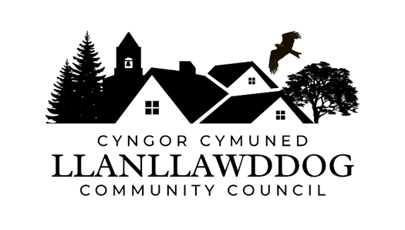
CYNGOR CYMUNED LLANLLAWDDOG
LLANLLAWDDOG COMMUNITY COUNCIL
75 Heol Pentre Felen, Llangyfelach, Abertawe / Swansea SA6 6DW
07968 033075
ccllanllawddogcc@gmail.com

Cynhelir cyfarfod arbennig o Gyngor Cymuned Llanllawddog yn Neuadd yr Eglwys, Llanllawddog a thrwy Microsoft Teams ar Nos Fercher 20 Fai 2026 am 6.30yh.

An extraordinary meeting of Llanllawddog Community Council will be held at the Church Hall, Llanllawddog and via Microsoft Teams on Wednesday 20 May 2026 at 6.30pm.

Dyddiedig/Dated: 14/05/2026

Nodyn: I gael mynediad i'r cyfarfod o bell trwy Microsoft Teams, cysylltwch â'r Clerc yn ccllanllawddogcc@gmail.com dim hwyrach na 2 awr cyn cychwyn y cyfarfod ar gyfer y ddolen wahoddiad.

Note: To access the meeting remotely via Microsoft Teams, please contact the Clerk at ccllanllawddogcc@gmail.com no later than 2 hours before the commencement of the meeting for the invitation link.

AGENDA

- Ymddiheuriadau am absenoldeb
Apologies for absence

2. Datganiadau o ddiddordeb
Declarations of interest

- Cais i Gefnogi Prosiect Strydoedd Trawsnewid Rhydargaeau
Request to Support Transition Streets Project Rhydargaeau

4. Ardal Chwarae Parc y Rhyd
Parc y Rhyd Play Area

- Cynllun Datblygu Lleol Diwygiedig Sir Gaerfyrddin 2018-2033
Revised Carmarthenshire Local Development Plan 2018-2033

6. Dyddiad y cyfarfod arferol nesaf – 29 Mehefin 2026
Date of next ordinary meeting – 29 June 2026

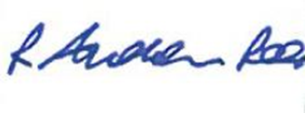
Andrew Rees
Clerc Cyngor Cymuned Llanllawddog Community Council Clerk

Aelodau Cyngor Cymuned Llanllawddog Community Council Members
Cynghorydd / Councillor Steven Mason (Cadeirydd / Chairperson)
Cynghorydd / Councillor Nia Bowen
Cynghorydd / Councillor Deborah Dean
Cynghorydd / Councillor Beth Gibbon
Cynghorydd / Councillor Havard Hughes
Cynghorydd / Councillor Philip Hughes
Cynghorydd / Councillor Darrell Lewis
Cynghorydd / Councillor Peter Williams

