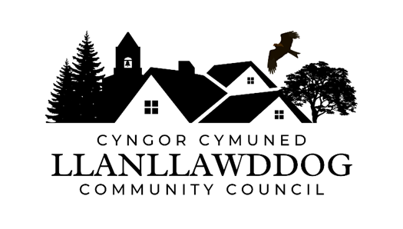

**CYNGOR CYMUNED LLANLLAWDDOG**

**LLANLLAWDDOG COMMUNITY COUNCIL**

75 Heol Pentre Felen, Llangyfelach, Abertawe / Swansea SA6 6DW

07968 033075

[ccllanllawddogcc@gmail.com](mailto:ccllanllawddogcc@gmail.com)

Cynhelir cyfarfod Blynyddol o Gyngor Cymuned Llanllawddog yn Neuadd yr Eglwys, Llanllawddog a thrwy Microsoft Teams ar **Nos Lun 12 Fai 2025 am 7.00yh.**

The Annual meeting of Llanllawddog Community Council will be held at the Church Hall, Llanllawddog and via Microsoft Teams on **Monday 12 May 2025 at 7.00pm.**

Dyddiedig/Dated: 06/05/2025

**Nodyn:** **I gael mynediad i'r cyfarfod o bell trwy Microsoft Teams, cysylltwch â'r Clerc yn** [**ccllanllawddogcc@gmail.com**](mailto:ccllanllawddogcc@gmail.com) **dim hwyrach na 2 awr cyn cychwyn y cyfarfod ar gyfer y ddolen wahoddiad.**

**Note: To access the meeting remotely via Microsoft Teams, please contact the Clerk at** **[ccllanllawddogcc@gmail.com](mailto:ccllanllawddogcc@gmail.com) no later than 2 hours before the commencement of the meeting for the invitation link.**

**AGENDA**

1. I Ethol Cadeirydd ar gyfer y flwyddyn ddinesig 2025-2026

Election of Chairperson for the Municipal Year 2025-2026.

2. Derbyn y datganiad o dderbyn swydd Cadeirydd

To receive the declaration of acceptance of office as Chairperson

3. Ethol Is-Cadeirydd ar gyfer y flwyddyn ddinesig 2025-2026

Election of Vice Chair of Council for the Municipal Year 2025-2026

4. Ymddiheuriadau am absenoldeb

Apologies for absence

5. Datganiadau o ddiddordeb

Declarations of interest

6. I gymeradwyo ac arwyddo cofnodion cyfarfod y Cyngor a gynhaliwyd ar 3 Mawrth 2025 chofnodion cyfarfod arbennig y Cyngor a gynhaliwyd ar 14 Ebrill 2025

To approve and sign the minutes of the meeting of Council held on 3 March 2025 and the minutes of the extraordinary meeting of Council held on 14 April 2025

7. Derbyn adroddiad y Cadeirydd am y flwyddyn ddinesig 2024-25

To receive the Chairperson’s report for the 2024-25 Municipal Year

8. Derbyn yr Adroddiad Blynyddol ar gyfer y flwyddyn 2024-25

To receive the Annual Report for the 2024-25 year

9. Adolygu'r Cynllun Hyfforddiant 2023-27

Review of Training Plan 2023-27

10. Adolygu’r Cofrestr Asedau

Review of Asset Register

11. Rheoliadau Ariannol Diwygiedig 2025

Revised Financial Regulations 2025

12. Penodi cynrychiolwyr ar amrhyw gyrff allanol ayyb

To appoint representatives on various outside bodies etc.

13. I gymeradwyo dyddiadau cyfarfodydd y Cyngor am y flwyddyn ddinesig 2025-26

To approve dates of meetings of Council for the 2025-26 Municipal Year

* Nos Lun 30 Mehefin 2025 / 30 June 2025
* Nos Lun 1 Medi 2025 / Monday 1 September 2025
* Nos Lun 3 Dachwedd 2025 / Monday 3 November 2025
* Nos Lun 5 Ionawr 2026 / Monday 5 January 2026
* Nos Lun 2 Mawrth 2026 / Monday 2 March 2026
* Nos Lun 11 Fai 2026 (Cyfarfod Blynyddol) / 11 May 2026 (Annual Meeting)

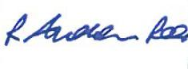

Andrew Rees

**Clerc Cyngor Cymuned  
Llanllawddog   
Community Council Clerk**

|  |
| --- |
| **Aelodau Cyngor Cymuned Llanllawddog Community Council Members** |
| Cynghorydd / Councillor Steven Mason (Cadeirydd / Chairperson) |
| Cynghorydd / Councillor Dr Nia Bowen |
| Cynghorydd / Councillor Deborah Dean |
| Cynghorydd / Councillor Beth Gibbon |
| Cynghorydd / Councillor Havard Hughes |
| Cynghorydd / Councillor Philip Hughes |
| Cynghorydd / Councillor Darrell Lewis |
| Cynghorydd / Councillor Peter Williams |