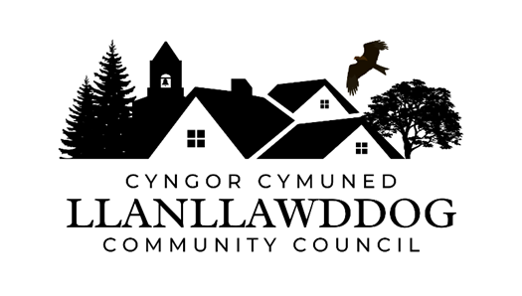

**CYNGOR CYMUNED LLANLLAWDDOG**

**LLANLLAWDDOG COMMUNITY COUNCIL**

75 Heol Pentre Felen, Llangyfelach, Abertawe / Swansea SA6 6DW

07968 033075

[ccllanllawddogcc@gmail.com](mailto:ccllanllawddogcc@gmail.com)

Cynhelir cyfarfod o Gyngor Cymuned Llanllawddog yn Neuadd yr Eglwys, Llanllawddog a thrwy Microsoft Teams ar **Nos Lun 12 Fai 2025 am 7.30yh.**

The meeting of Llanllawddog Community Council will be held at the Church Hall, Llanllawddog and via Microsoft Teams on **Monday 12 May 2025 at 7.30pm.**

Dyddiedig/Dated: 06/05/2025

**Nodyn:** **I gael mynediad i'r cyfarfod o bell trwy Microsoft Teams, cysylltwch â'r Clerc yn** [**ccllanllawddogcc@gmail.com**](mailto:ccllanllawddogcc@gmail.com) **dim hwyrach na 2 awr cyn cychwyn y cyfarfod ar gyfer y ddolen wahoddiad.**

**Note: To access the meeting remotely via Microsoft Teams, please contact the Clerk at** **[ccllanllawddogcc@gmail.com](mailto:ccllanllawddogcc@gmail.com) no later than 2 hours before the commencement of the meeting for the invitation link.**

**AGENDA**

1. Ymddiheuriadau am absenoldeb

Apologies for absence

2. Datganiadau o ddiddordeb

Declarations of interest

3. Cronfa Gymunedol Fferm Wynt Brechfa

Brechfa Wind Farm Community Fund

4. I Dderbyn Adroddiad y Cynghorydd Sir

To Receive the Report of the County Councillor

5. Ardal Chwarae Parc y Rhyd

Parc y Rhyd Play Area

6. Monitro’r gyllideb am y cyfnod yn diweddu 30 Ebrill 2025

Budget monitoring relative to the period ending 30 April 2025

7. Biliau i'w talu

Bills for payment

8. Diogelwch Priffordd ar yr A485

Road Safety on the A485

9. Rhaglen Gwaith

Work Programme

10. Adroddiad Blynyddol Panel Annibynnol Cymru ar Gydnabyddiaeth Ariannol

Independent Remuneration Panel for Wales Annual Report

11. Ceisiadau am Gymorth Ariannol

Applications for Financial Assistance

12. Casglaid Sbwriel Cymunedol

Community Litter Pick

13. Llwybrau Troed ac Heolydd Ceffylau

Footpaths and Bridleways

14. Hysbysfyrddau

Noticeboards

15. Derbyn gohebiaeth

To receive correspondence

16. Ceisiadau cynllunio

Planning applications

17. Adroddiadau o gyfarfodydd

Reports of meetings

18. Dyddiad y cyfarfod arferol nesaf – 30 Mehefin 2025

Date of next ordinary meeting – 30 June 2025

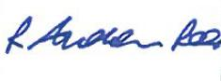

Andrew Rees

**Clerc Cyngor Cymuned Llanllawddog Community Council Clerk**

|  |
| --- |
| **Aelodau Cyngor Cymuned Llanllawddog Community Council Members** |
| Cynghorydd / Councillor Steven Mason (Cadeirydd / Chairperson) |
| Cynghorydd / Councillor Nia Bowen |
| Cynghorydd / Councillor Deborah Dean |
| Cynghorydd / Councillor Beth Gibbon |
| Cynghorydd / Councillor Havard Hughes |
| Cynghorydd / Councillor Philip Hughes |
| Cynghorydd / Councillor Darrell Lewis |
| Cynghorydd / Councillor Peter Williams |