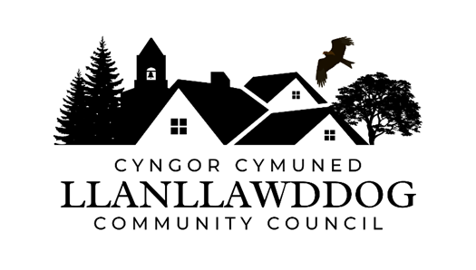

**CYNGOR CYMUNED LLANLLAWDDOG**

**LLANLLAWDDOG COMMUNITY COUNCIL**

75 Heol Pentre Felen, Llangyfelach, Abertawe / Swansea SA6 6DW

07968 033075

[ccllanllawddogcc@gmail.com](mailto:ccllanllawddogcc@gmail.com)

Cynhelir cyfarfod arbennig o Gyngor Cymuned Llanllawddog yn Neuadd yr Eglwys, Llanllawddog a thrwy Microsoft Teams ar **Nos Lun 14 Ebrill 2025 am 7.00yh.**

An extraordinary meeting of Llanllawddog Community Council will be held at the Church Hall, Llanllawddog and via Microsoft Teams on **Monday 14 April 2025 at 7.00pm.**

Dyddiedig/Dated: 08/04/2025

**Nodyn:** **I gael mynediad i'r cyfarfod o bell trwy Microsoft Teams, cysylltwch â'r Clerc yn** [**ccllanllawddogcc@gmail.com**](mailto:ccllanllawddogcc@gmail.com) **dim hwyrach na 2 awr cyn cychwyn y cyfarfod ar gyfer y ddolen wahoddiad.**

**Note: To access the meeting remotely via Microsoft Teams, please contact the Clerk at** **[ccllanllawddogcc@gmail.com](mailto:ccllanllawddogcc@gmail.com) no later than 2 hours before the commencement of the meeting for the invitation link.**

**AGENDA**

1. Ymddiheuriadau am absenoldeb

Apologies for absence

2. Datganiadau o ddiddordeb

Declarations of interest

3. Parc y Rhyd, Rhydargaeau

Parc y Rhyd, Rhydargaeau

4. Ymateb i Ymgynghoriad Prosiect Green GEN Cymru Tywi Teifi

Response to Consultation on Green GEN Cymru Towy Teifi Project

5. Derbyn adroddiad ar sefyllfa ariannol y Cyngor am y flwyddyn yn diweddu 31

Mawrth 2025

To receive a report on the Council’s financial position for the year ending 31

March 2025

6. Biliau i'w talu

Bills for payment

7. Dyddiad y cyfarfod arferol nesaf – 12 Mai 2025

Date of next ordinary meeting – 12 May 2025

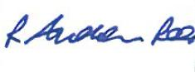

Andrew Rees

**Clerc Cyngor Cymuned Llanllawddog Community Council Clerk**

|  |
| --- |
| **Aelodau Cyngor Cymuned Llanllawddog Community Council Members** |
| Cynghorydd / Councillor Steven Mason (Cadeirydd / Chairperson) |
| Cynghorydd / Councillor Nia Bowen |
| Cynghorydd / Councillor Deborah Dean |
| Cynghorydd / Councillor Beth Gibbon |
| Cynghorydd / Councillor Havard Hughes |
| Cynghorydd / Councillor Philip Hughes |
| Cynghorydd / Councillor Darrell Lewis |
| Cynghorydd / Councillor Peter Williams |